SpecterX Platform Governance Rules
Administrator Guide — Configuration, Enforcement & Operational Impact
Platform Governance Rules (Governance Rules) allow administrators to define how SpecterX governs file sharing across the organization — automatically, consistently, and in real time.
Instead of relying on user judgment or post-event review, Governance Rules evaluates every share at the moment it is created or modified and applies the organization’s defined governance decisions before access is granted.
This guide explains:
- How rules are configured
- How rules are evaluated
- How enforcement behaves
- How users are affected
- How audit logs reflect governance decisions
- How this creates scalable, low-friction governance

1. How Platform Governance Rules Work
Every time a share changes, SpecterX evaluates all Active rules against the current share state.
Evaluation is triggered when:
- A new share is created
- A recipient is added or removed
- A file is added or removed
Governance Rules evaluates the full context of the share, including:
- Sender identity
- Recipient identity or domain
- Internal vs external context
- File sensitivity (if applicable)
This ensures governance decisions are applied consistently and automatically — without requiring manual oversight.
Value: Governance becomes embedded in the workflow. Users continue working normally, while enforcement happens invisibly and predictably.

2. Where Enforcement Applies
Platform Governance Rules apply across:
- SpecterX WebUI
- SharePoint Connector
- Mail Connector (attachments only)
For email:
- The message itself is never blocked
- Attachment access may be modified or restricted
Enforcement occurs before file access is provisioned. This prevents unauthorized access rather than reacting after exposure.

3. How Governance Decisions Are Made
Before configuring rules, it is important to understand how the enforcement engine evaluates them.
Every time a share is created or modified, SpecterX evaluates all Active rules in a consistent order.
Evaluation follows this sequence:
- Exception Rules
- Block Rules
- Policy Assignment Rules
This order is fixed.
Within Policy Assignment rules, order is meaningful.
They are evaluated top-to-bottom, and the first matching rule determines the policy outcome.
The system does not combine multiple policy rules.
The first applicable rule defines the result.
This means:
- Exceptions can suppress enforcement.
- Blocks can restrict recipients or files.
- Policy Assignment determines protection when no Exception overrides and no Block invalidates the share.
Understanding this order is critical when designing governance logic.

3.1 The Three Possible Outcomes (Rule Actions)
Every rule defines one outcome. The action determines what the system will do when the rule’s conditions match.

Policy Assignment
When conditions match:
- The selected protection policy is automatically applied.
- The policy becomes locked.
- Users cannot modify the policy while conditions remain true.
If multiple Policy Assignment rules could apply, the first matching rule (based on order) determines the policy.
This enables contextual protection — the right policy is applied automatically based on who is sharing, who is receiving, and what is being shared.

Block
When conditions match:
- Matching recipients are not added.
- Matching files are not made accessible.
Blocking is granular.
If at least one valid file and recipient remain → the share proceeds.
If no valid share state remains → the share is cancelled (WebUI & SharePoint).
For email:
- The message sends.
- Attachments may be partially or fully blocked.
Blocking prevents high-risk sharing without unnecessarily stopping legitimate collaboration.

Exception
When conditions match:
- Block rules are not applied.
- Policy Assignment rules are not applied.
- The user-selected policy remains editable.
Exceptions are evaluated first.
They allow organizations to enforce strong baseline governance while preserving flexibility for trusted scenarios.

4. How Scope Is Defined (Conditions)
If Actions define the outcome, Conditions define the scope.
A rule only applies when its conditions match the current share state.
Supported condition categories:
- Sender (From)
- Recipient (To)
- Domain (External / Public)
- Microsoft Purview Sensitivity Label (if integrated)

4.1 Empty vs Specified Fields
Each condition field is evaluated independently.
If a field is left empty: The rule applies to all values for that category.
If values are specified: The rule applies only to those values.
Example:
- Recipient specified, Sender empty → applies when those recipients receive a share from any sender.
- Both empty → applies to all shares.
Empty does not disable a rule, but rather it expands its reach.
Administrators should intentionally review empty fields to avoid unintentionally broad scope.

4.2 Condition Matching Logic
Within a condition category:
At least one listed value must match.
Across categories:
All populated categories must match.
Example:
If Sender = Finance
AND Recipient = External Domains
Both must be true for the rule to trigger.
This structure enables precise governance aligned to business context.

4.3 Sensitivity Label Integration
If Microsoft Purview is integrated:
- Sensitivity labels are available as a selectable condition.
- Rules can match files based on classification.
If not integrated:
- Classification-based conditions are unavailable.
Label matching occurs at share-time evaluation.
This allows classification investments to directly influence automated enforcement decisions.

5. Configuring Rules in the Admin Portal
Once the evaluation model is understood, rules can be authored in the Governance Rules Configuration Module within the Admin Management Portal.
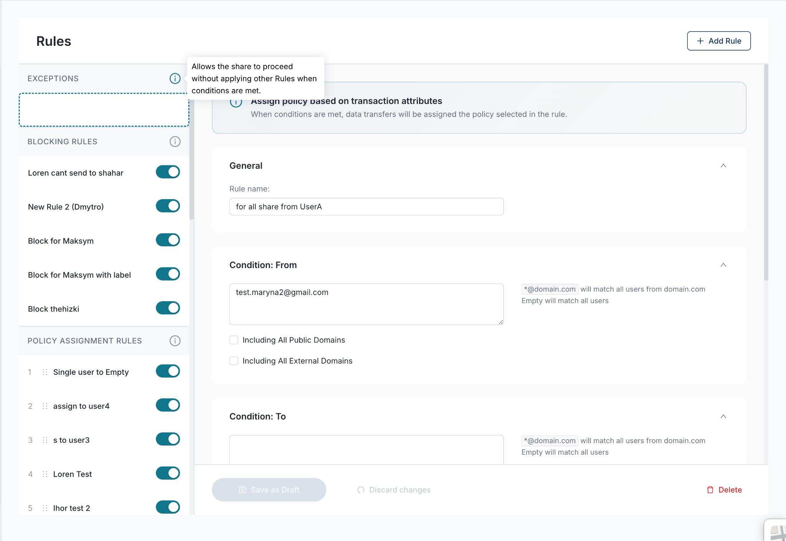

The console mirrors the enforcement engine:
- Rules are grouped by action type.
- Policy Assignment rules are ordered and can be dragged to change positioning.
- Toggle controls determine whether a rule is Active.
When creating or editing a rule, you define:
- Rule Name
- Action
- Conditions
In simple terms:
Action = Outcome
Conditions = Context
Together, they define a governance decision that will be applied automatically at share time.

5.1 Rule Lifecycle and Activation
Rules exist in three states:
Draft — Editing only
Saved (Inactive) — Stored but not evaluated
Active — Participates in enforcement
Only Active rules affect user behavior.
Activation requirements:
- Must have a unique name.
- Must define an action.
- Must include at least one valid condition.
- Must not include any invalid conditions.
Unsaved changes never affect enforcement.

5.2 Rule Name Visibility
Calling out that Rule names are published to data owners but conditions are not - so keep this in mind when configuring.

6. What Users Experience
Platform Governance Rules are designed to minimize friction while enforcing policy.
Users may experience:

Automatic Policy Assignment
- A policy is pre-selected
- The policy dropdown becomes locked

Governance Rules Blocking
- A specific recipient cannot be added
- A specific file is not accessible

Share Prevention
- If no valid share state remains, the share does not proceed
Enforcement is contextual and transparent — it does not require users to interpret policy requirements.
Value: Governance becomes predictable and explainable, reducing policy confusion and inconsistent protection.

7. Policy Lock Behavior
When a Policy Assignment rule triggers:
- The policy becomes locked
- The lock persists only while the rule conditions remain true
If:
- The rule is deactivated
- The share conditions change
The lock releases on the next evaluation cycle.
Locks are dynamic — they reflect active governance requirements.
Administrative clarity: Locks indicate rule-driven enforcement, not manual restriction.

9. Audit Logs — Understanding Enforcement Decisions
Every rule-triggered enforcement action generates an audit record.
Audit entries include:
- Rule name
- Rule action
- Enforcement result
- Share event type (new share or modification)
If a share involves multiple recipients and some are blocked:
- Enforcement is summarized per share event
- The audit reflects the rule that acted
Audit logs record governance decisions — not UI states.
Why this matters:
Administrators can trace:
- Why a policy was locked
- Why a recipient was blocked
- Which rule triggered
- When enforcement occurred
This supports compliance reporting, troubleshooting, and policy validation.

The Outcome for Administrators
Platform Governance Rules centralize governance into a single, configurable framework.
You define:
- The boundaries of collaboration
- The level of protection required
- The scenarios where flexibility is allowed
SpecterX applies those decisions automatically, consistently, and in real time.
The result is:
- Reduced reliance on user judgment
- Reduced DLP alert review
- Consistent policy enforcement
- Seamless, scalable governance aligned to business needs

